Experiments

Program 1: Design a simple web page with head, body and footer, with heading tags, image tag (your CV).

Html Code :
<!DOCTYPE html>
<html lang="en">
<head>
<meta charset="UTF-8">
<meta name="viewport" content="width=device-width", initial-scale=1.0">
<title>My CV</title>

</head>
<body>
<header>
<!--Design a web page with head, body and footer,with heading tags,image tags (your CV)-->
<h1> Hiii !! <br> I'm Krishna Namdev</h1>
<img src="/img/my pic.jpg" alt="my pic" width="300px">

<p>An enthusiastic and dedicated Bachelor's of Computer Applications student at Sage
University passionate about full-stack web development and data science. <br>
Eager to leverage
software skills and proficiency in languages like C, HTML, CSS, JavaScript, and Python,
along with expertise in ReactJS, to contribute to innovative projects in the tech industry</p>
</header>
<main>
<h2>My Skills :</h2>
<ul>
<li>Software skills : windows 11 ,10 , Linux , MacOS</li>
<li>Computer language: C , HTML , CSS , JavaScript , Python</li>
<li> Communication : English (fluent) , Hindi</li>
</ul>

<h2> Education :</h2>
<table border="1">
<tr>
<th>S.No</th>
<th>Board of Education</th>
<th>class</th>
<th>percentage</th>
<th>Year of Passing</th>
</tr>
<tr>
<td>1</td>
<td>CBSE</td>
<td>10th</td>
<td>87%</td>
<td>2020-2021</td>
</tr>
<tr>
<td>2</td>
<td>CBSE</td>
<td>12th</td>
<td>83%</td>
<td>2022-2023</td>
</tr>
</table>

<h2>Area of Interest :</h2>
<dl>
<dt> Full Stack Web Development:- </dt>
<dd> Passionate about creating immersive and functional web
applications, adept at utilizing various technologies and frameworks.
</dd>
<dt>Data Science:-</dt>
<dd>Fascinated by the insights that data can unveil, seeking to apply analytical
skills to derive meaningful conclusions from complex datasets</dd>
</dl>
</main>
<footer>
<h2>Contact Me :-</h2>
<p>Mobile number:- 7224971949</p>
<p>email:- krishnamdev282@gmail.com</p>
<p>Address:- 1558/21 Nanda nagar ,Indore</p>
</footer>
</body>
</html>

Output :

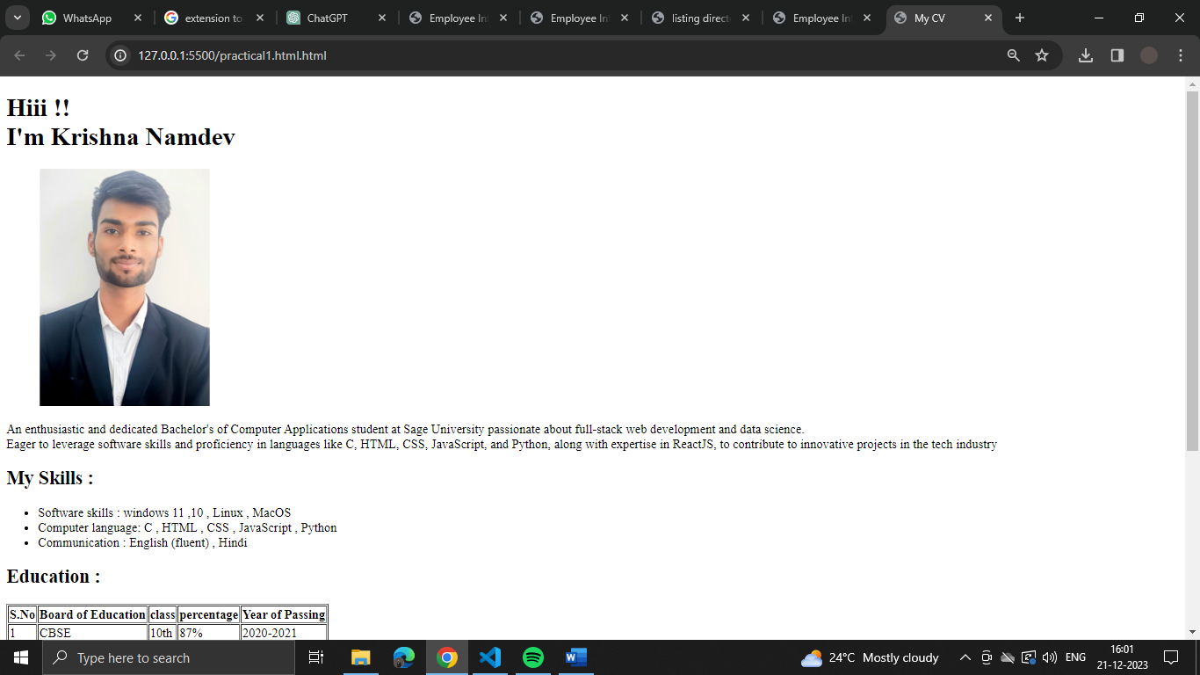

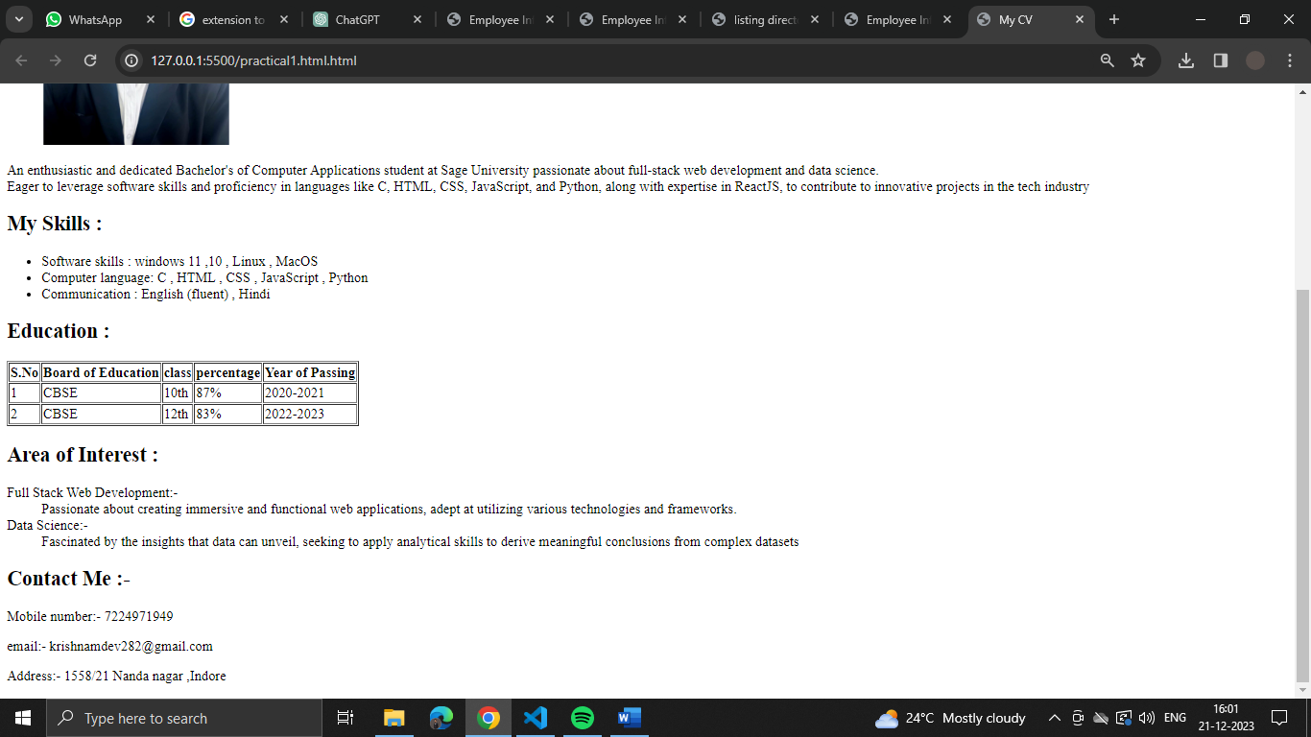

Program 2: Design a web site for book information, home page should contain books list, when particular book is clicked, information of the books should display in the next page. (Use <a> tag for)
Html Code :
Home Page :-
<!DOCTYPE html>
<html lang="en">
<head>
<meta charset="UTF-8">
<meta name="viewport" content="width=device-width, initial-scale=1.0">
<title>Book List</title>
</head>
<body>
<h1>The Given Books Names Are:- </h1>
<ul>
<li><a href="book 1.html" target="_blank">(Power of your Subconsicious Mind)</a></li> <br>
<li><a href="book 2.html" target="_blank">(Atomic Habits)</a></li><br>
<li><a href="book 3.html" target="_blank">( Monk who sold his Ferrari)</a></li><br>
</ul>
</body>
</html>

Power of your subconsicious Mind :-
<!DOCTYPE html>
<html lang="en">
<head>
<meta charset="UTF-8">
<meta name="viewport" content="width=device-width, initial-scale=1.0">
<title>Book 1</title>
</head>
<body>
<h1>Book name: <b>Power of your Subconsicious Mind </b> </h1>
<img src="/img/power of subcon.jpg" alt="" width="200px">
<p> Author : Joseph Murphy</p>
<p> Publisher : Penguin, 2011</p>
<p> Published : 1963</p>
<p>Price : 200 rs</p>
<br>
<a href="HomeBook.html" target="_blank"> Go back to main page.</a>
</body>
</html>

Atomic Habits :-
<!DOCTYPE html>
<html lang="en">
<head>
<meta charset="UTF-8">
<meta name="viewport" content="width=device-width, initial-scale=1.0">
<title>Book 2</title>
</head>
<body>
<h1>Book name :Atomic Habits </h1>
<img src="/img/atomic habits.jpg" alt="" width="200px">
<p>Author: James Clear </p>
<p> Publisher : The Russian Messenger</p>
<p>Published : 16 October 2018</p>
<p> Price : 310rs</p>
<a href="HomeBook.html" target="_blank"> Go back to main page.</a>
</body>
</html>

Monk who sold his Ferrari :-
<!DOCTYPE html>
<html lang="en">
<head>
<meta charset="UTF-8">
<meta name="viewport" content="width=device-width, initial-scale=1.0">
<title>Book 3</title>
</head>
<body>
<h1>Book name: The Monk Who Sold His Ferrari</h1>
<img src="/img/monk who.jpg" alt="" width="200px">
<p>Author: Robin Sharma</p>
<p> Publisher: penguin</p>
<p> published : 1996</p>
<p> Price: 355rs </p>
<a href="HomeBook.html" target="_blank"> Go back to main page.</a>
</body>
</html>

Output :-

Homepage :-
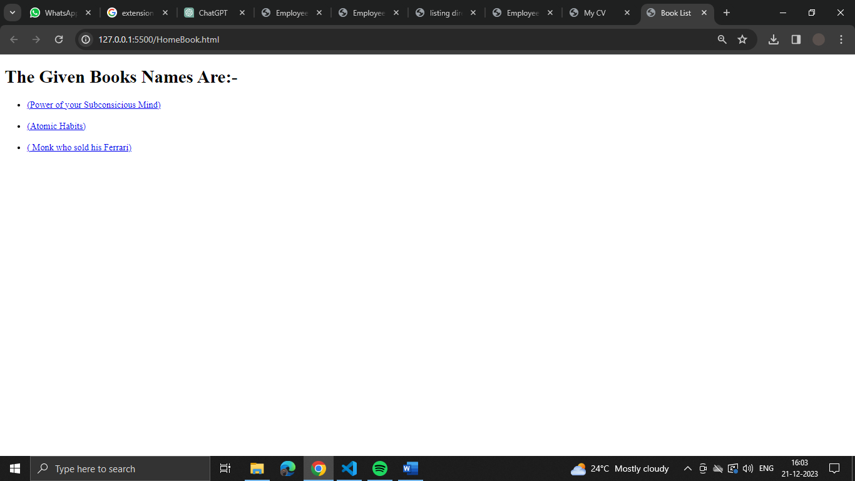

Power of your subconsicious Mind :-
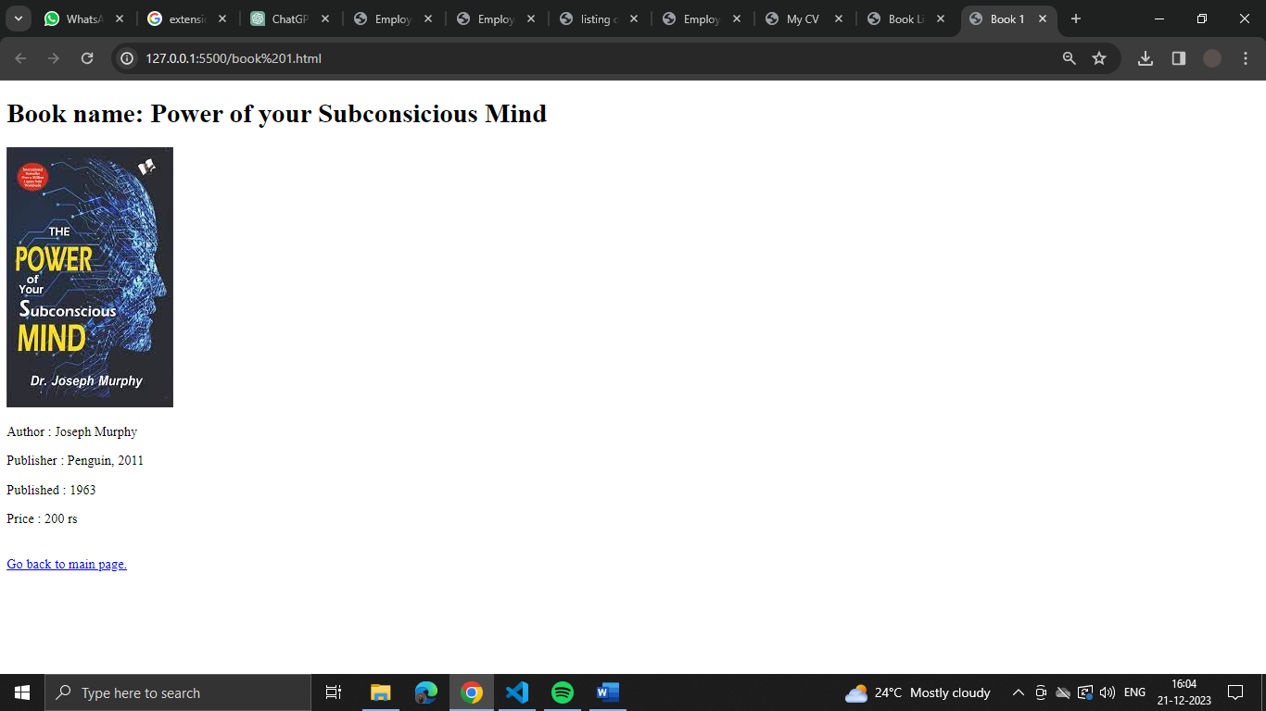
Atomic Habits :-
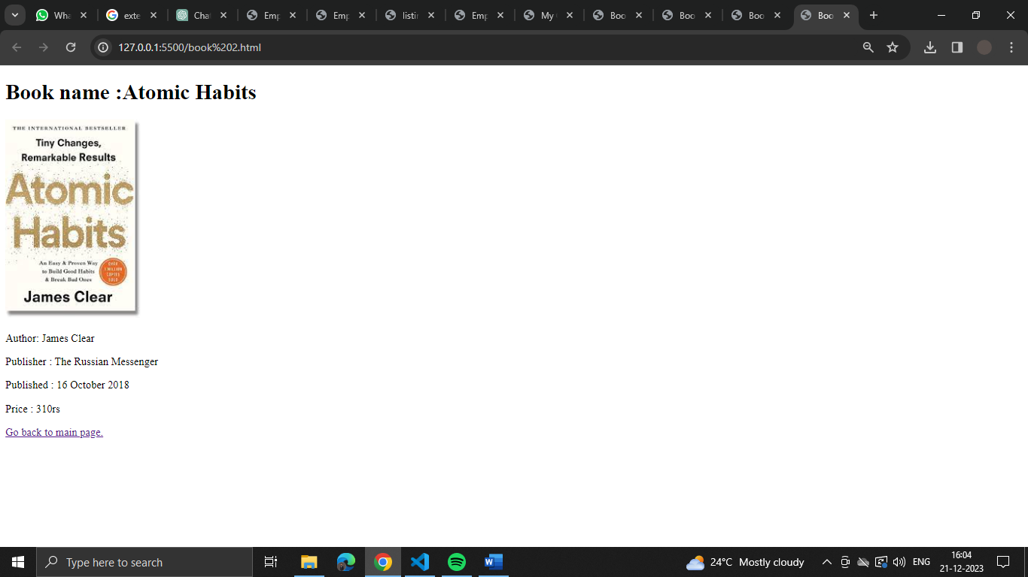

Monk who sold his Ferrari :-

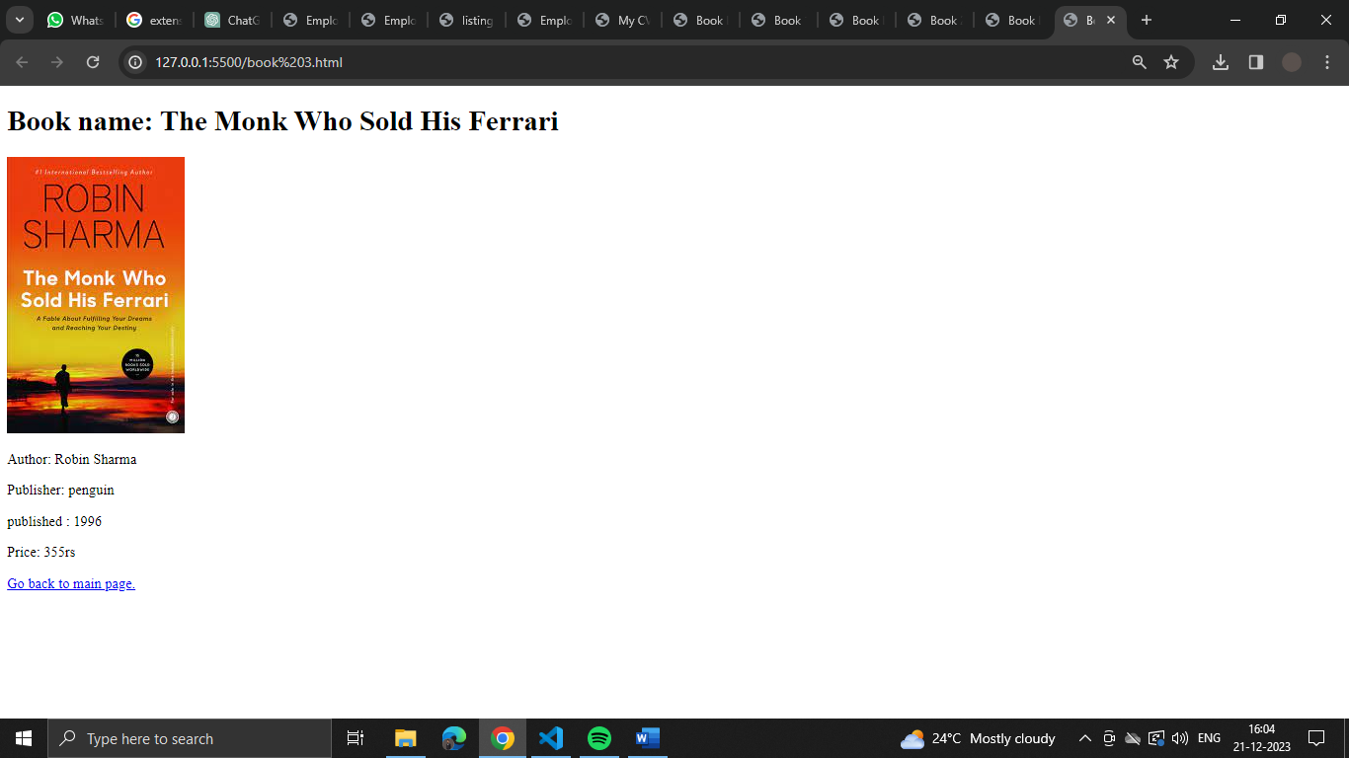

Program 3 : Design a page to display the product information such as name, brand, price and etc with table tag .
Html Code :
<!DOCTYPE html>
<html lang="en">
<head>
<meta charset="UTF-8">
<meta name="viewport" content="width=device-width, initial-scale=1.0">
<title>Amazon</title>
<style>
table {
border-collapse: collapse;
margin-top: 20px;
}

th, td {
border: 1px solid #ddd;
padding: 8px;
text-align: center;
}
</style>
</head>
<body>

<h2>Products:-</h2>

<table>
<tbody>
<tr>
<td style="background-color: #a5a1a1;"><b>IMAGE</b></td>
<td><img style="height: 200px;" src="/img/earpode.jpg"; alt="no image found"></td>
<td><img style="height: 200px;" src="/img/speaker.jpg" alt="no image found"></td>
<td><img style="height: 200px;" src="/img/headphone.jpg" alt="no image found"></td>
</tr>
<tr>
<td style="background-color: #a5a1a1;"><b>NAME</b></td>
<td>EarBuds</td>
<td>Speaker</td>
<td>Headphone</td>
</tr>
<tr>
<td style="background-color: #a5a1a1;"><b>BRAND</b></td>
<td>Portronics </td>
<td>Boat</td>
<td>JBL</td>
</tr>
<tr>
<td style="background-color: #a5a1a1;"><b>PRICE</b></td>
<td>935</td>
<td>1,599</td>
<td>2,700</td>
</tr>
<tr>
<td style="background-color: #a5a1a1;"><b>DESCRIPTION</b></td>
<td>The lightweight TWS earphones weigh only 3.5 grams, with 8.5mm dynamic drivers and a micro case design</td>
<td>Stone 352 portable speaker is stylish, cool and trendy. the stone 352 stereo sound w. equipped with IPX7 Splash </td>
<td>JBL Tune 510BT, On Ear Wireless Headphones with Mic, up to 40 Hours Playtime, Pure Bass, Quick Charging, Dual Pairing, Bluetooth 5.0.</td>
</tr>
</tbody>
</table>

</body>
</html>

Output :

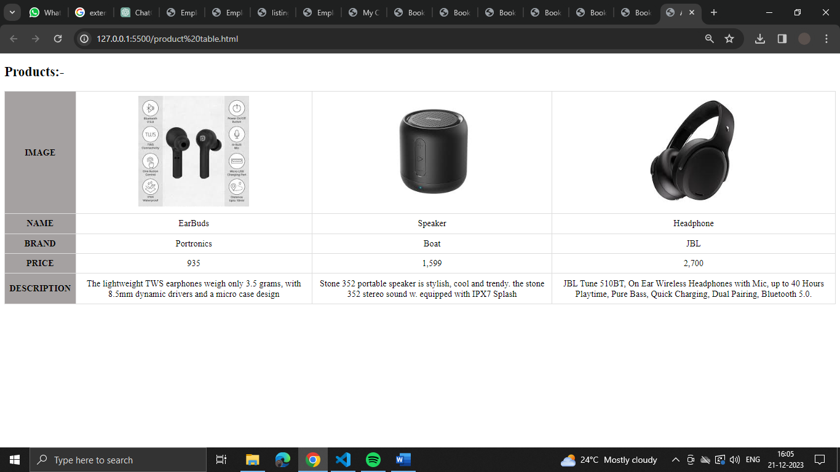

Program 4 : Design a web page to capture the user information such as name, gender, mobile number, mail id, city, state, and country using form elements. (This is your Form HTML code)

Html Code :-

<!DOCTYPE html>
<html lang="en">
<head>
<meta charset="UTF-8">
<meta name="viewport" content="width=device-width, initial-scale=1.0">
<title>Google form</title>
</head>
<body>
<h1 style="text-align: center;"><u>FORM</u></h1>
<form action="D:\formdata.html" method="post">
<label for="firstName">First Name : </label>
<input type="text" name="lastName" id="firstName" ><br><br>

<label for="lastName">Last Name : </label>
<input type="text" name="lastName" id="lastName" ><br><br>

<label for="gender"> Gender :</label>
<p> <input type="radio" name="gender" id="gender" value="Male" > Male </p>
<p> <input type="radio" name="gender" id="gender" value="Female"> Female </p><br><br>

<label for="phone">Contact number :</label>
<input type="number" name="phone number" id="phone"><br><br>

<label for="email">Email Id :</label>
<input type="email" name="Email" id="email"><br><br>

<label for="DOB">Date of birth :</label>
<input type="date" name="DOB" id="DOB"><br> <br>

<label for="pin">Pincode :</label>
<input type="password" name="pincode" id="pin" step="1" > <br><br>

<label for="city">City Name :</label>
<input type="text" name="City" id="city" ><br><br>

<label for="state">State Name :</label>
<input type="text" name="State" id="state" ><br><br>

<label for="country"> Country Name :</label>
<input type="text" name="Country" id="country" ><br><br>

<input type="reset" value="Reset All">

<input type="submit" value="submit"> <br>
</form>

</body>
</html>

Output : -

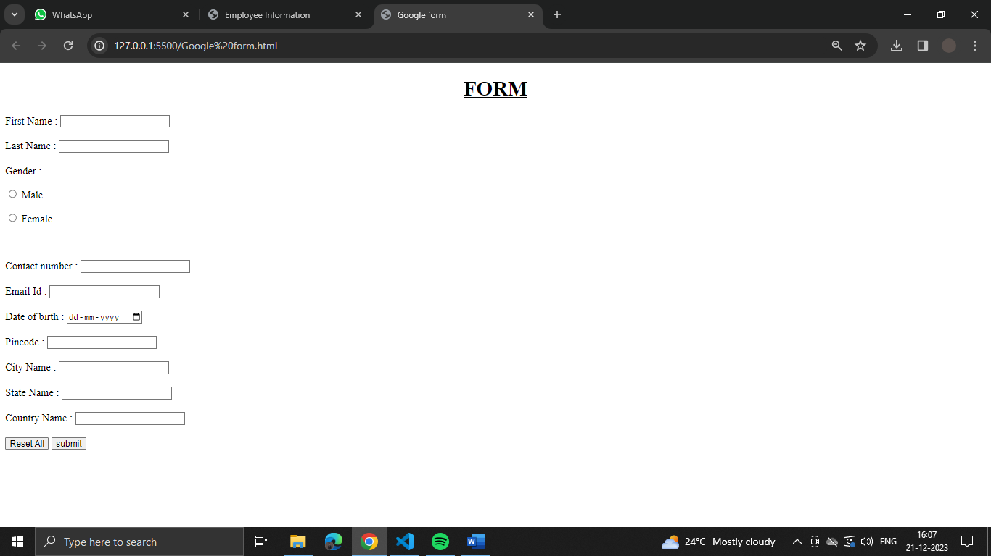

Program 5 : Design a web page with nice form atting like background image, text colors and border for text using external CSS. (Style Your Resume HTML page)

Html Code :
<!DOCTYPE html>
<html lang="en">
<head>
<meta charset="UTF-8">
<meta name="viewport" content="width=device-width", initial-scale=1.0">
<title>My Resume</title>
<link rel="stylesheet" href="MyResume.css">

</head>
<body>
<h1 style="text-align: center;"><span style=" color: rgb(0, 0, 0);"><u>RESUME</u></span></h1>
<header>

<h1> Krishna Namdev</h1>
<img src="/img/my pic.jpg" alt="my pic" width="300px" style="border: 5px solid rgb(218, 209, 209) ;"> <br><br>

<h2>About Me :</h2>

<p>An enthusiastic and dedicated Bachelor's of Computer Applications student <br> at Sage
University passionate about full-stack web development <br>and data science.
Eager to leverage
</p>
</header>
<main>
<h2>My Skills :</h2>
<ul>
<li>Software skills : windows 11 ,10 , Linux , MacOS</li>
<li>Computer language: C , HTML , CSS , JavaScript , Python</li>
<li> Communication : English (fluent) , Hindi</li>
</ul>

<h2> Education :</h2>
<table border="1">
<tr>
<th>S.No</th>
<th>Board of Education</th>
<th>class</th>
<th>percentage</th>
<th>Year of Passing</th>
</tr>
<tr>
<td>1</td>
<td>CBSE</td>
<td>10th</td>
<td>87%</td>
<td>2020-2021</td>
</tr>
<tr>
<td>2</td>
<td>CBSE</td>
<td>12th</td>
<td>83%</td>
<td>2022-2023</td>
</tr>
</table>

<h2>Area of Interest :</h2>
<dl>
<dt> Full Stack Web Development:- </dt>
<dd> Passionate about creating immersive and functional web
applications, adept at utilizing various technologies and frameworks.
</dd>
<dt>Data Science:-</dt>
<dd>Fascinated by the insights that data can unveil, seeking to apply analytical
skills to derive meaningful conclusions from complex datasets</dd>
</dl>
</main>
<footer>
<h2>Contact Me :-</h2>
<p>Mobile number:- 7224971949</p>
<p>email:- krishnamdev282@gmail.com</p>
<p>Address:- 1558/21 Nanda nagar ,Indore</p>
</footer>
</body>
</html>

CSS Code :-

body{
background-image:url("/img/backg.jpg");
background-size: 100%;
font-family: Arial, Helvetica, sans-serif;
}

Output :-
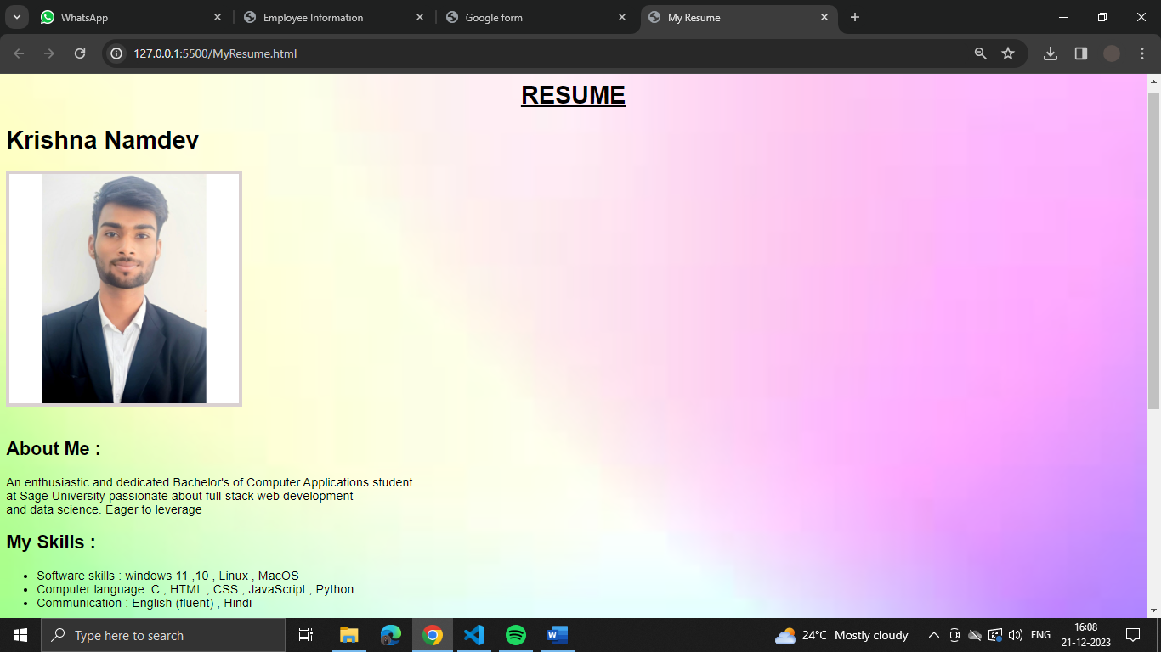

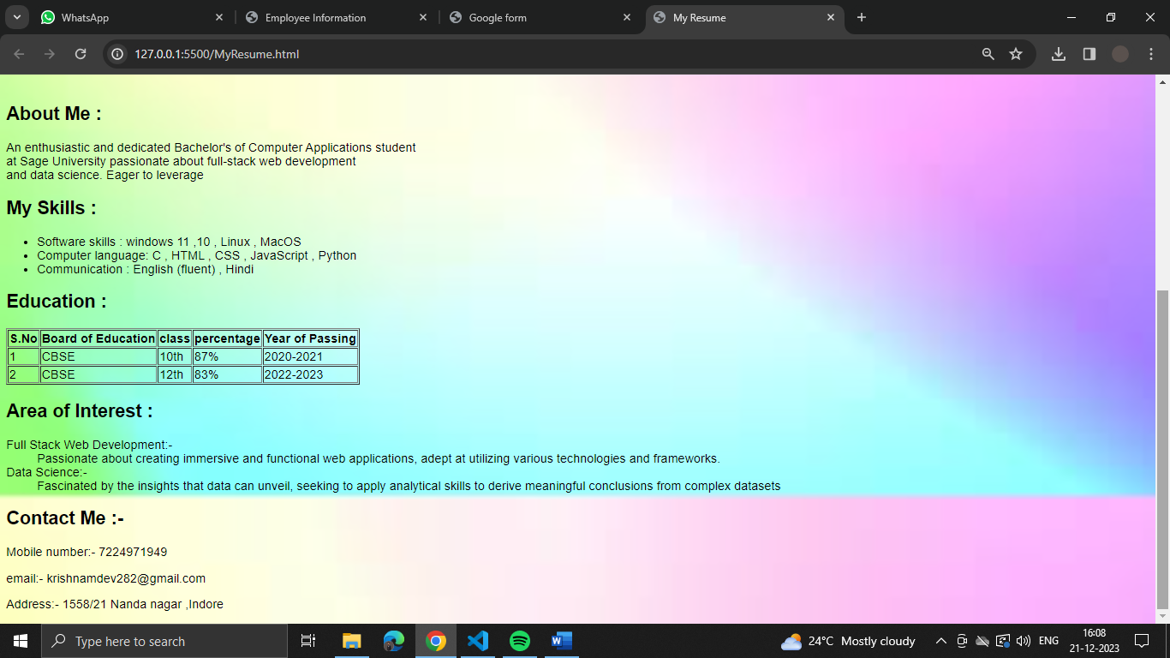

Program 6 :-Design a web page to perform mathematical calculations such as addition, subtraction, multiplication, and division using form elements and Java Script. (Create a Calculator page)

Html Code :-
<!DOCTYPE html>
<html lang="en">
<head>
<meta charset="UTF-8">
<meta name="viewport" content="width=device-width, initial-scale=1.0">
<link rel="stylesheet" href="style.css">
<title>Calculator</title>
</head>
<body>
<div class="calculator">
<input type="text" id="display" readonly>
<div class="buttons">
<button onclick="clearDisplay()">C</button>
<button onclick="appendToDisplay('/')">/</button>
<button onclick="appendToDisplay('*')">*</button>
<button onclick="appendToDisplay('7')">7</button>
<button onclick="appendToDisplay('8')">8</button>
<button onclick="appendToDisplay('9')">9</button>
<button onclick="appendToDisplay('-')">-</button>
<button onclick="appendToDisplay('4')">4</button>
<button onclick="appendToDisplay('5')">5</button>
<button onclick="appendToDisplay('6')">6</button>
<button onclick="appendToDisplay('+')">+</button>
<button onclick="appendToDisplay('1')">1</button>
<button onclick="appendToDisplay('2')">2</button>
<button onclick="appendToDisplay('3')">3</button>
<button onclick="calculateResult()">=</button>
<button onclick="appendToDisplay('0')">0</button>
<button onclick="appendToDisplay('.')">.</button>
</div>
</div>
<script src="script.js"></script>
</body>
</html>

CSS Code :-
body {
display: flex;
justify-content: center;
align-items: center;
height: 100vh;
margin: 0;
}

.calculator {
border: 1px solid #ccc;
border-radius: 5px;
padding: 10px;
text-align: center;
}

#display {
width: 100%;
margin-bottom: 10px;
padding: 5px;
font-size: 1.5em;
}

.buttons {
display: grid;
grid-template-columns: repeat(4, 1fr);
gap: 5px;
}

button {
padding: 10px;
font-size: 1em;
cursor: pointer;
}

JavaScript Code :-
let display = document.getElementById('display');

function appendToDisplay(value) {
display.value += value;
}

function clearDisplay() {
display.value = '';
}

function calculateResult() {
try {
display.value = eval(display.value);
} catch (error) {
display.value = 'Error';
}
}

OutPut:-

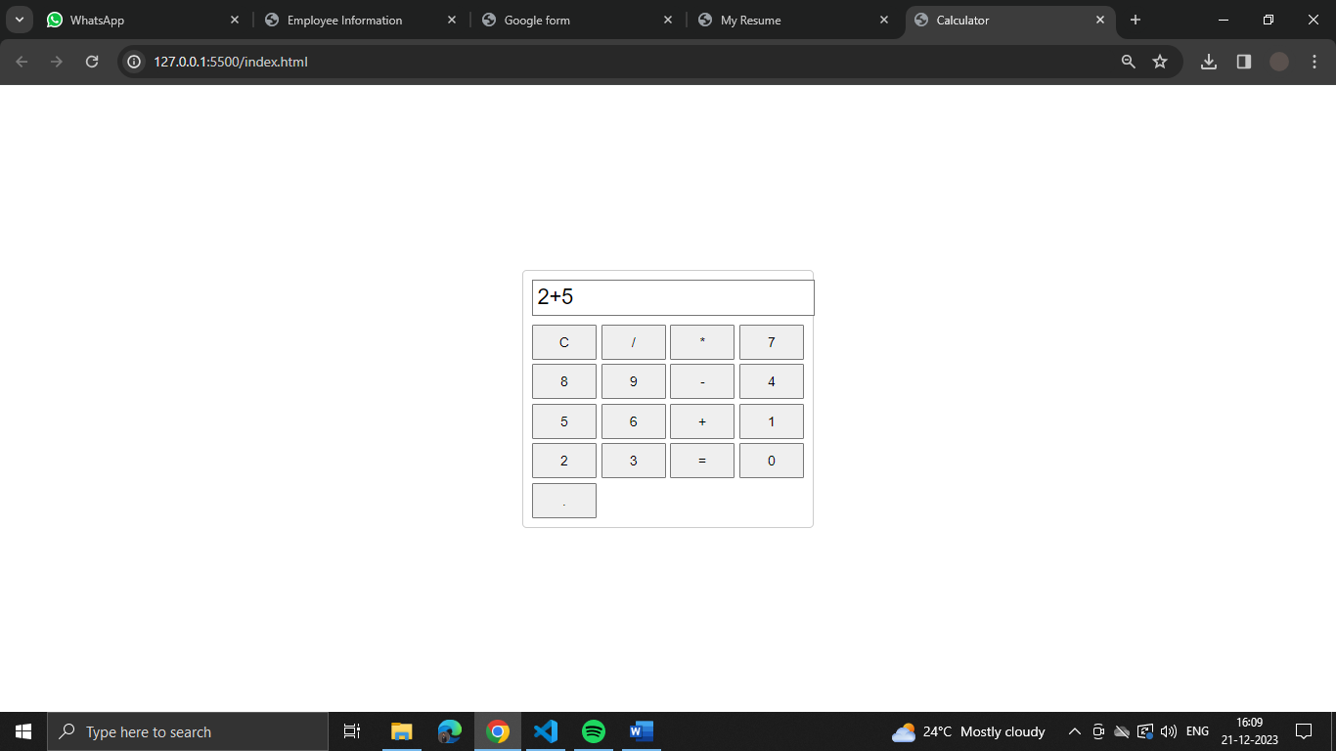

Program 7 :- Design a web page to read data from an XML file and display the data in tabular form at, take the data as employee information.
Html Code :-
<!DOCTYPE html>
<html lang="en">
<head>
<meta charset="UTF-8">
<meta name="viewport" content="width=device-width, initial-scale=1.0">
<title>Employee Information</title>
<link rel="stylesheet" href="employe.css">

</head>
<body>
<h1>Employee Information</h1>
<table id="employeeTable">
<thead>
<tr>
<th>ID</th>
<th>Name</th>
<th>Position</th>
<th>Department</th>
</tr>
</thead>
<tbody id="tableBody"></tbody>
</table>

<script src="employe.js"></script>
</body>
</html>

CSS Code :-

body {
font-family: Arial, sans-serif;
margin: 20px;
}

h1 {
text-align: center;
}

table {
width: 100%;
border-collapse: collapse;
margin-top: 20px;
}

th, td {
border: 1px solid #ddd;
padding: 8px;
text-align: left;
}

th {
background-color: #f2f2f2;
}

JavaScript Code :-
document.addEventListener('DOMContentLoaded', async function () {
try {
// Fetch XML file
const response = await fetch('employe.xml');
const data = await response.text();

// Parse XML
const parser = new DOMParser();
const xmlDoc = parser.parseFromString(data, 'text/xml');

// Extract employee information
const employees = xmlDoc.querySelectorAll('employee');
const tableBody = document.getElementById('tableBody');

// Display data in the table
employees.forEach(employee => {
const id = employee.querySelector('id').textContent;
const name = employee.querySelector('name').textContent;
const position = employee.querySelector('position').textContent;
const department = employee.querySelector('department').textContent;

const row = `<tr>
<td>${id}</td>
<td>${name}</td>
<td>${position}</td>
<td>${department}</td>
</tr>`;

tableBody.innerHTML += row;
});
} catch (error) {
console.error('Error:', error);
}
});

Xml Code :-

<?xml version=”1.0” encoding=”UTF-8”?>
<employees>
<employee>
<id>1</id>
<name>John Doe</name>
<position>Software Developer</position>
<department>IT</department>
</employee>
<employee>
<id>2</id>
<name>Jane Smith</name>
<position>Marketing Specialist</position>
<department>Marketing</department>
</employee>
<!—Add more employee entries as needed ◊
</employees>

OutPut :-
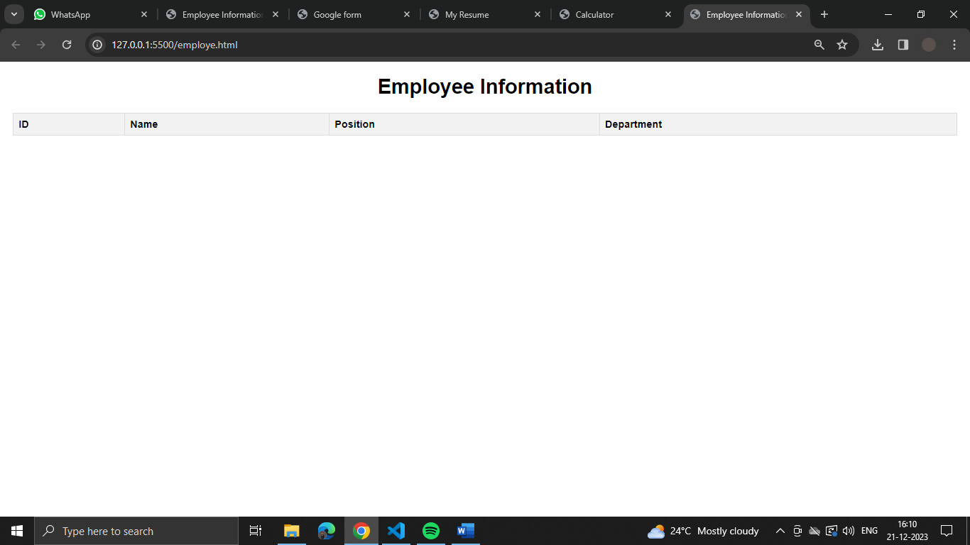

Program 8:- Inserting value in a form check that inserted value is even or odd (USE PHP)
Html Code :-
<!DOCTYPE html>

<body>

<form method="post">

<h2>Enter a number:</h2>

<input type="number" name="number">

<input type="submit" value="Submit">

</form>

</body>

</html>

<?php

if($_POST){

$number = $_POST['number'];

//divide entered number by 2

//if the reminder is 0 then the number is even otherwise the number is odd

if(($number % 2)=0){

echo "$number is an Even number";

}else{

echo "$number is Odd number";

}

}

?>

Output :-

